Constant definitions:

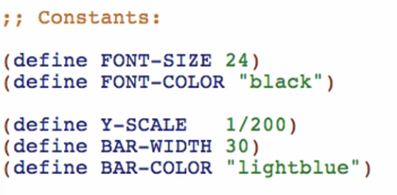

Y-SCALE is for:

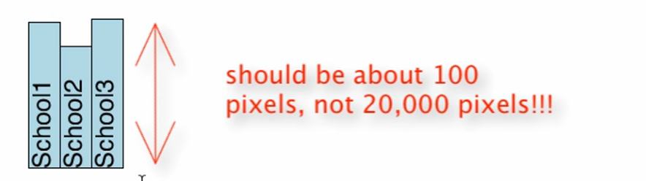

Data Definitions:

1. Compound Data Definition: School
   * Information about individual schools
2. Arbitrary List Data Definition: ListOfSchools
   * Arbitrary list with the individual schools

Compound Data Definition: School

1. Structure (define-struct)



1. Type Comment



1. Interpretation



1. Examples



1. Templates

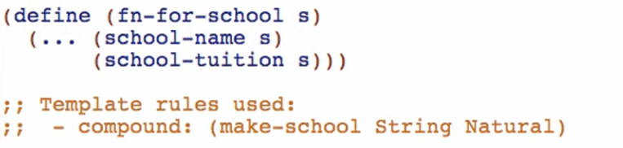

Arbitrary List Data Definition: ListOfSchool

1. Type Comment

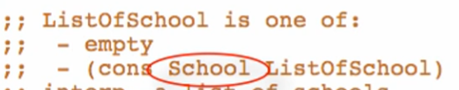

* + - Compound data type

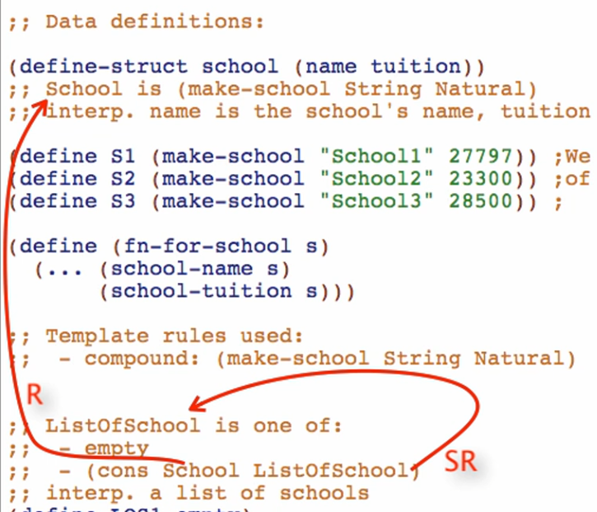

* + - This will be labeled as “Reference”. A reference to the compound data definition that we made

1. Interpretation



1. Examples



1. Templates

One of 2 cases:

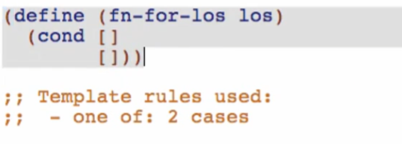

First case: atomic distinct empty

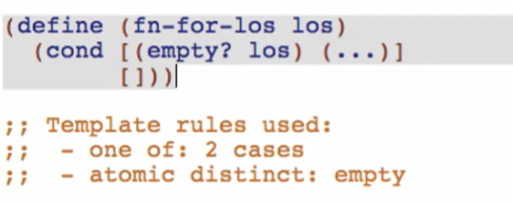

2nd case: compound list

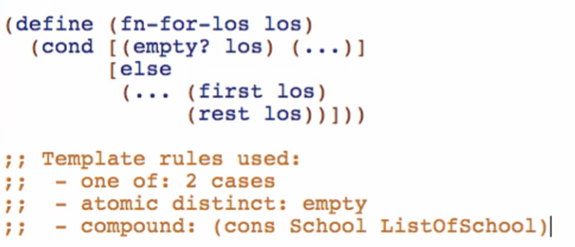

4th case: self-reference rule

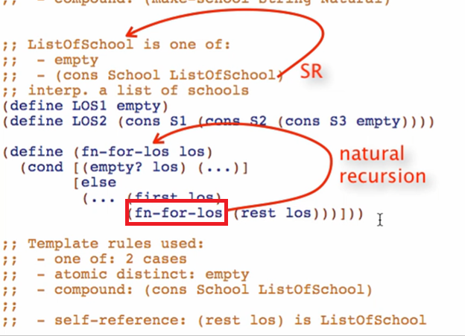

* + - This function is called a natural **recursion**

3rd case: reference rule

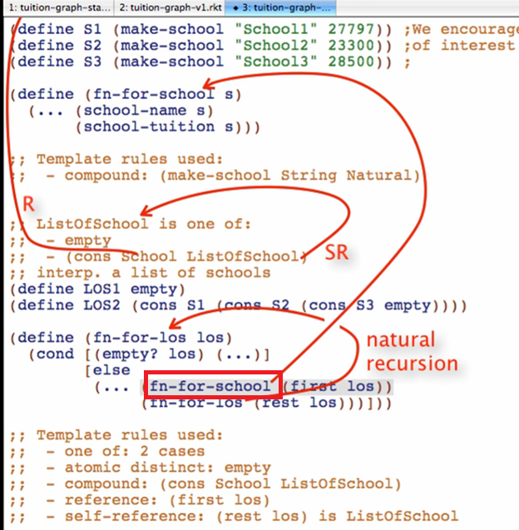

* + - This function is called a natural **helper**

Overview:

